**Materials:**

Print copies of “GraphPaperProgrammingWorksheet” for all students. Print half as many copies of “GraphPaperProgrammingBlanks,” and cut them out.

**Lesson Plan:**

First, go over 2 important definitions:

Algorithm: A list of steps that you can follow to finish a task

Program: An algorithm that has been coded into something that can be run by a machine

Draw a 4x4 square graph on the board. We are going to guide each other to fill in a drawing on 4x4 graphs. First, fill in the same squares pictured below. Tell students we always start in the top left corner of the graph. Ask for step-by-step instructions to fill in those squares.

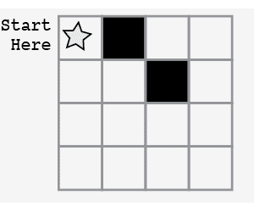

Instructions should be:

* Move to the right
* Fill in that square
* Move down
* Move to the right
* Fill in that square

Then, introduce a code to make it quicker and easier to give directions:

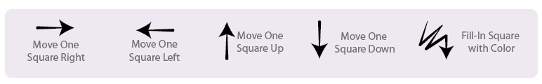

Rewrite the previous directions with these symbols. Next, have the students use these symbols to draw a picture of their choice, giving instructions one by one, working together.

Finally, pass out the worksheets and the blanks (3 per student), and 1 blank sheet of paper per student. Instruct students to pick 1 pattern and write the code for it. Then, have them switch with a neighbor and use the neighbor’s code to draw a pattern. Repeat 2 more times.